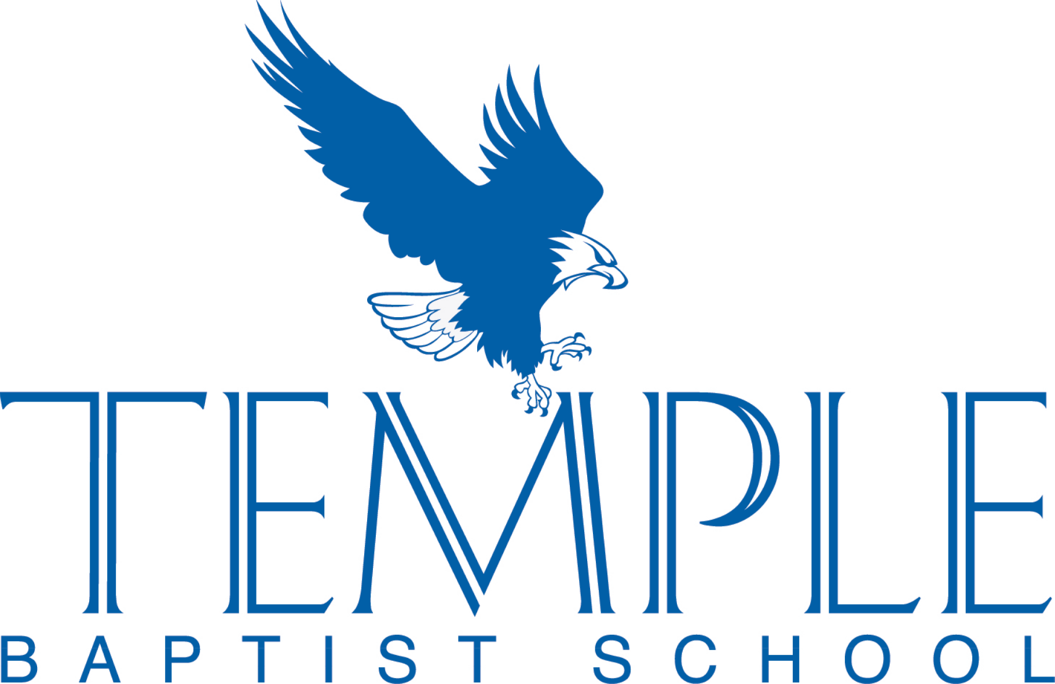

**2024-2025CALENDER OF EVENTS**

**(Revised 06/05/24)**

**August**

5 Monday Teachers’ In-Service Days Begin

12 Monday Parent-Student Orientation 9:00 AM K-12th

13 Tuesday First **FULL** Day of School

**September**

2 Monday Labor Day – **No School**

25 - 27 Wednesday - Friday NCCSA Educators’ Convention - **No School**

**October**

11 Friday Grandparents’ Day (K4-6th Grades) / **½ Day of School**

15 Tuesday End of the First Quarter Grading Period

25 Friday Fall Festival

**November**

11 Monday Veterans’ Day Holiday – **No School**

27 - 29 Wednesday - Friday Thanksgiving Holidays – **No School**

**December**

5 Thursday Christmas Program

18 - 20 Wednesday - Friday Semester Exams Grades 7th-12th.

20 Friday **Half Day of School;** End of Second Quarter Grading Period

Christmas Holidays from Noon through January 3 – **No School**

**January**

6 Monday School Resumes; Start of the Third Quarter Grading Period

10 Friday Homecoming

20 Monday MLK Holiday – **No School**

27 - 31 Monday-Friday Spirit Week

**February**

1. Saturday First day for Opportunity Scholarship Reapplication
2. Monday Re-enrollment for the 2025-2026 School Year Begins

17 Monday Presidents’ Day – **No School**

***Over***



*Over*

**(Revised 06/05/2024)**

**March**

3 Monday Open Enrollment for New Students

11 Tuesday End of Third Quarter Grading Period

17 Monday “Week of Giving” Kickoff

27, 28 Thursday-Friday Iowa Testing (grades 1-11)

**April**

3/31 - 4 Thursday - Friday Standardized Testing (grades 1 – 11)

11 Friday Jr/Sr Banquet

14 – 18 Monday-Friday Easter Break – **No School**

25 Friday NCCSA Elementary Fine Arts Competition

26 Saturday Sports Award Ceremony

**May**

15 Thursday Kindergarten Graduation 7:00 PM; Last Day of School for K4-K5

19 - 21 Monday-Wednesday Final Exams 7th-12th Grades

21 Wednesday 1/2 day of school

22 Thursday Teacher Workday - **No School**

23 Friday **Last Day of School** / High School Graduation 7:00 PM